**DEPARTMENT**

**OF**

**ELECTRICAL AND ELECTRONICS ENGINEERING**

**SELF STUDY ASSIGNMENT – 1**

**20EE4101 – CONTROL SYSTEMS**

|  |  |
| --- | --- |
| **Name** | **:B.VARSHA** |
| **Register No.** | **: 811722105051** |
| **Year / Sec** | **: II** |

**Marks Awarded:**

|  |  |  |  |  |  |  |
| --- | --- | --- | --- | --- | --- | --- |
| **Objective**  **(3)** | **Context and**  **Relevance**  **(4)** | **Technology aspects and relevant**  **drawings**  **(4)** | **Emerging trends ideas**  **(4)** | **Conclusion**  **(3)** | **References**  **(2)** | **Total (20)** |
|  |  |  |  |  |  |  |

|  |  |  |
| --- | --- | --- |
| **Assignment Topic** | **CO** | **PO addressed** |
| Construct the block diagram for DC motor for both armature control and field control methods. | 1,2,3 | PO1, PO2, PO3, PO4, PO12 |

CO-1

**Introduction:**

DC drives offer the ability to control the speed and torque of heavy-duty DC motors in various industrial and other similar applications. Speed control can be achieved using DC drives in a number of ways. Voltage can be applied to the terminals of the [DC motor](https://www.carotron.com/articles/dc-ac-drives-checklist/) or external resistance can be applied in the armature.

Another method is to vary the flux per pole of the motor. The first two methods involve adjusting the motor’s armature while the latter method involves adjusting the motor field. These methods are referred to as “armature control” and “field control.”

**Technology involved with relevant diagrams:**

**ARMATURE CONTROL:**

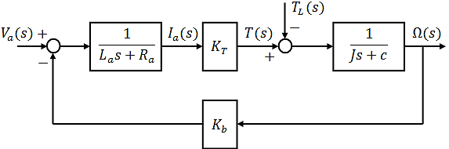

**FIELD CONTROL:**

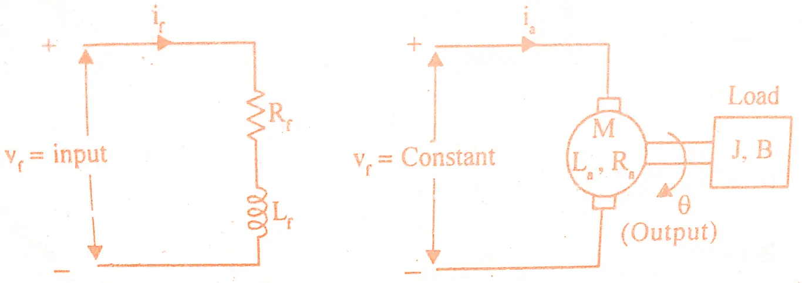

 Rf = Field resistance

                   Lf = Field inductance

                   if = Field current

                   Vf= Field voltage

                   T = Torque developed by motor

                  Kt = Torque constant

                   J = Moment of inertia of rotor and load

                   B = Frictional coefficient of rotor and load

**Emerging Trends related to this Technology:**

The speed characteristic of a shunt motor is different compared with a series motor. As a DC Shunt motor attains its complete speed, then the armature current can be directly connected to the motor load. When the load is extremely low within a shunt motor, then the **armature current** can also be below. When the DC motor attains its complete speed, then it remains stable.

**Conclusion:**

In the realm of industrial automation, the transfer function of field-controlled DC motors stands as a critical tool for engineers and designers. Its ability to capture the intricate relationship between input voltage and motor speed empowers them to optimize motor performance, design efficient control systems, and ensure stability and reliability in diverse applications. By delving into the components, significance, and real-world applications of the transfer function, we gain a deeper appreciation for the role these motors play in driving technological advancements across industries.

**References**

1. Automatic Feedback Control System Synthesis: John C.

2. Introduction to Automatic Control: Keisuke Izaka, Elsevier Pub, London.

CO-2

Consider second order system, draw the output response curve for overdamped system.

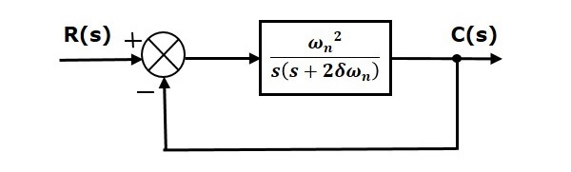

Here, an open loop transfer function, ω2n/s(s+2δωn) is connected with a unity negative feedback.

We know that the transfer function of the closed loop control system having unity negative feedback as

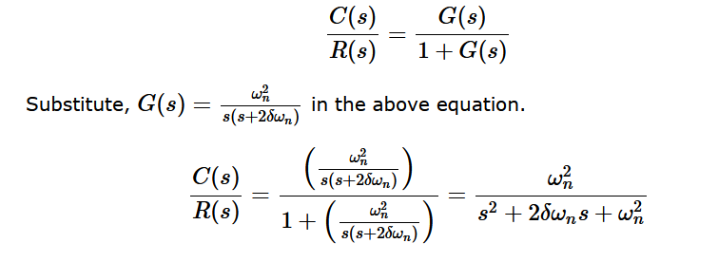

The power of ‘s’ is two in the denominator term. Hence, the above transfer function is of the second order and the system is said to be the **second order system**.

The characteristic equation is:

s2+2δωns+ω2n=0

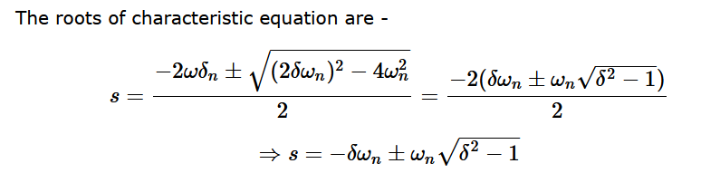

We can write *C*(*s*) equation as,

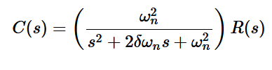

Where,

* **C(s)** is the Laplace transform of the output signal, c(t)
* **R(s)** is the Laplace transform of the input signal, r(t)
* **ωn** is the natural frequency
* **δ** is the damping ratio.

Follow these steps to get the response (output) of the second order system in the time domain.

